Standalone bushfire plan
2024-2025
Paraburdoo Primary School

Purpose

The Standalone bushfire plan document is a detailed plan of how your school is to prepare and respond to a catastrophic fire danger rating alert or to a bushfire event.

As principal, you must complete this template to have a plan in place to respond to a bushfire emergency. This plan is to be read in conjunction with information on Ikon to prepare for bushfire season at your school.

All staff, students, contractors and visitors on the school or facility site are to follow this completed plan in the event of a bushfire emergency. All other emergencies are to be managed in accordance with the school’s incident management plan, as per the Incident management manual.

Complete and lodge your plan online by 31 August.

Contents
1 School details 3
2 Emergency response contact list 4
2.1 Important bushfire emergency contact sources 5
3 School Response Team 6
4 Bushfire response telephone tree 7
5 Emergency equipment 8
6 Bushfire preparation checklist 9
7 Bushfire action plan maps 11
7.1 Onsite ‘safer building location(s)’ 11
7.2 Offsite evacuation locations 12
Appendix A - Bushfire warning stages 13
Appendix B - Procedures in the event of a sudden bushfire 14
Relocate to onsite ‘safer building location’ 14
Offsite evacuation procedures 16
Appendix C - Pre-emptive (planned) closure procedures 18
Flow chart – Principal’s response to Fire Behaviour Index of 75 (Extreme Fire Danger Rating) or greater 19
Appendix D – After-hours or school holiday procedures 20

1 School details

To complete this plan, on the front cover of the document:
- insert your school name
- add the year for the new bushfire season
- add the date in the footer to show when the plan became active.

Enter information into the grey sections of this document, following the prompts in the square brackets where featured. You can add extra rows to tables where necessary.

When your plan is complete, follow the steps on Ikon to lodge, update or access your standalone bushfire plan online.

School name  (include name of co-located school or facilities if applicable) | Paraburdoo Primary School
School address | De Grey Rd, Paraburdoo
Education Region | Pilbara
Number of students | 200
Number of students requiring extra support if evacuating | 3 (as of T3, 2024 – high transiency requires referral to individual documented planning/SAER spreadsheet).
Number of staff | 35
Estimated number of animals on site, if applicable | N/A
Estimated number of animals on site that would require evacuation, if applicable | N/A
Number of school sides bordered by bush | 1
Names of major roads bordering school | 0
School’s site-specific alert, for example:  - siren/pause x 3  - continuous handbell  - continuous siren or short whistle blasts | Emergency evacuation signal over PA ‘Evacuate…Evacuate…Evacuate…’  For shelter in place  ‘Lock down, lock down, lock down…’

Plan prepared by  (principal’s name) | Caragh Livingstone
Date prepared or reviewed | Prepared September 2024

2 Emergency response contact list

Enter the contact details into the following table:

Organisation | Details | Phone number / website
Local police  (for example, name of nearest police station) | Paraburdoo Police (may divert to Karratha if station is unmanned)  Tom Price Police | 08 9159 8600  08 9188 022
Local hospital  (name of nearest hospital or medical emergency facility) | Paraburdoo Hospital  Paraburdoo Medical Clinic  Tom Price Hospital  Tom Price Medical Clinic | (08) 5159 8222  (08) 9189 5069  (08) 9159 5222  (08) 9189 1901
Department of Fire and Emergency Services regional contact | Paraburdoo Volunteer fire and Rescue  Tom Price Fire and Rescue | 000  9189 6111  9188 1333
Local fire brigade  (for example, name of nearest fire station) | Paraburdoo Fire and Rescue Service | 000
Local bushfire brigade  (for example name of nearest station) | NA
Bus contractors  (ready for pre-emptive closure or offsite evacuation) | NA  Buses not available in  location and offsite evacuation is  working distance for all students  and staff, including those  requiring support.
Electricity provider - in the case of a power outage  (for example, Horizon Power, Western Power) | Rio Tinto Utilities | 1800 992 777 (option 5)
State emergency service (if known) | SES Tom Price | 132 500
Poisons information (where relevant) | WA Poisons Information Centre | 131 126
Director of Education name | Ash King (PERO) | 9185 0111

2.1 Important bushfire emergency contact sources

DIAL 000 in an emergency

- Emergency WA
  - Website: https://www.emergency.wa.gov.au/

- Department of Fire and Emergency Services
- Information line: 13 33 37
- Website: https://www.dfes.wa.gov.au/
- Facebook: https://www.facebook.com/dfeswa
- Twitter: https://twitter.com/dfes_wa

- ABC Emergency
  - Website: https://www.abc.net.au/emergency

- Local radio
  - ABC local radio: Find your local radio station at https://www.abc.net.au/local
  - 6PR: Listen online at https://www.6pr.com.au/listen-live/ or tune into AM 882 and Digital Radio

3 School Response Team

Enter the names and mobile numbers of the staff responsible for carrying out emergency procedures during a bushfire event. The principal coordinates the incident response to onsite or offsite locations (refer to Appendix B & C procedures).

Examples of suggested duties include:
- fire warden duties
- checking all rooms
- keeping a copy of school registers for roll call
- monitoring the bushfires warnings stages (as per Appendix A)
- send out text alerts to parents
- liaising with emergency services, community members, parents and carers
- enacting plan for animal welfare in an emergency if applicable.

Consider making cards that outline the duties of the school response team. This can be useful to hand out at the start of the incident.

Position | Staff name | Duties | Mobile number
Principal | Caragh Livingstone | - Refer to emergency procedures posted in all rooms for specific actions in case of evacuation.  - Monitoring incoming information.  - Liaising with regional office and services.  - Managing internal and external communication.  - Coordinating response, including delegation of response tasks as necessary. | 0459 769 601
Deputy Principal | Tabitha Haddock  Danielle Smith | Refer to emergency procedures posted in all rooms for specific actions in case of evacuation | 0408 795 990
Manager Corporate Services | Karen Gaff | Refer to emergency procedures posted in all rooms for specific actions in case of evacuation. | 0459 224 416
Teachers |  | Refer to evacuation procedure posted in all rooms for specific actions in case of evacuation.
Accredited first aid officers | Nicole Leighton | Provide support at muster point or as needed. | 0414 066 761
Other (if applicable)

4 Bushfire response telephone tree

Complete the information boxes with the contact details for the relevant stakeholders.

Parents
Send emergency SMS templates to notify.
Neighbouring schools:
Tom Price SHS (many PPS students have siblings attending, info sharing may be helpful). School is located 80km away in Tom Price.

9188 3650

Community hirers
Name: St John
Mobile: 9188 1795
Buses
NA:
Canteen
NA
Out-of-hours childcare
Name: One Tree
Mobile: 9189 6403
School Council, Board or P&C
Name: Phil Boatwright
Mobile: 0427 357 749
Community Kindergarten
NA
Manager Corporate Services
Name: Karen Gaff
Mobile: 0459 224 416
Emergency response contact list
(refer to Section 2)
Staff
Send emergency SMS if school is closed.
Deputy Principal
Name: Tabitha Haddock
Mobile: 0408 795 990
Department’s Security and Emergency Management Unit
T: (08) 9264 4632
Media Unit
T: (08) 9264 5821

Principal
Name: Caragh Livingstone
Mobile: 0459 769 601
Coordinator Regional Operations
Name: Ian Knapgate
Mobile: 0460 001 593
Director of Education
Name: Ash King
Mobile:

5 Emergency equipment

Identify the location and the type of emergency equipment at your site.

Equipment | Details  (include location/s, date checked and any other comments)
Evacuation kit (section 7 of the school Incident Management Plan). | Admin – behind school officer desk in cabinet  Checked September 2024
First aid kit(s) - include masks in case some students are susceptible to smoke. | Admin – medical bay – on bench. Additional supplies in medical bay drawers as required. Medication including spare epipens and Ventolin in medical cupboard. Controlled medications are in locked cabinet.
Emergency alert system and communication equipment, for example:  - mobile telephones (charged)  - hand-operated fire alarm (portable siren)  - megaphone/loud hailer  - portable CB radios  - spare batteries. | Mobile phones (personal, all staff encouraged to carry)  Admin mobile phone (managed by school officer)  PA system  Battery operated megaphones  Portable radios in charger  Spare batteries in admin – school officer desk cabinet and in emergency kit
Registers for:  - students  - staff  - visitors. | Manged through Passtab (visitors) and Integris (students and staff). Printed by school officers in emergency.
Standalone bushfire plan:  - hard copy in the evacuation kit  - copy saved to an online platform for access offsite. | Updated September 2024

6 Bushfire preparation checklist
Principals must:
- complete this bushfire preparation checklist annually
- inform all staff members of their responsibilities.

You can provide details of your preparation activities in the comments.

Management activities | ☑ or N/A | Comments
The annual review of the Standalone bushfire plan has been completed before the start of bushfire season. | Yes
Consulted and received advice in preparing your Standalone bushfire plan from any of the following(as relevant):  - local Emergency Services  - Department of Fire and Emergency Services  - Department of Biodiversity, Conservation and Attractions – Parks and Wildlife Service  - local volunteer fire brigade  - WA Police Force  - local emergency management committee (LEMC) or local government representative  - community emergency services manager, if there is one for the area. | Yes
Staff have been made aware of the Standalone bushfire plan through:  - staff meetings  - staff bushfire induction session that includes:  - an overview of the Standalone bushfire plan  - how to turn off evaporative air conditioner units, the location of switches  - how to close roof vents  - the types of bushfire warnings issued by the Department of Fire and Emergency Services and the Emergency Alert telephone warning system  - to direct bushfire media enquiries to the Department’s media unit (08) 9264 5821. | Yes | Shared via weekly staff memo
Students and parents or carers have been made aware of the Standalone bushfire plan through:  - key bushfire safety messages incorporated into the curriculum  - newsletters  - school information booklet (include actions and procedures)  - school website. | Yes | School newsletter, school website
Communication plans are in place:  - Emergency response contact list completed (section 2).  - Bushfire response telephone tree completed (section 4).  - communication templates for sample emergency text message, newsletter content and school notice text are complete (refer to Appendix D).  Contact lists for staff and parents must be current. | Yes
Emergency equipment available and checked (section 5):  - evacuation kit checked at least once per term  - emergency warning or alert system works  - emergency communications equipment available  - first aid kit(s) available  - animal emergency kit  - registers for students, staff and visitors readily accessible for roll call. | Yes
Practise drills moving to your onsite ‘safer building location(s)’:  - before the start of the bushfire season  - at least once per term during the bushfire season.  You must do at least 2 drills per year. | Yes
The asset protection zone, which is a minimum distance of 20 metres surrounding the main school buildings, is checked and is:  - clear of all rubbish, long dry grass, bark, flammable and combustible materials, including leaf litter and unused piles of mulch  - maintained routinely throughout the year.  For information on the asset protection zone, refer to Prepare for bushfire season at your school on Ikon. | Yes

7 Bushfire action plan maps

7.1 Onsite ‘safer building location(s)’

Do not use an open area such as a school oval or non-enclosed building that may expose people to heat or other conditions.

Insert your school map and make sure it is marked with:
- the onsite ‘safer building locations(s)’. Include the name of the building, such as ‘library’
- routes to access the location
- fire hydrants
- electrical switchboards
- phones and communication board
- first aid kits
- evacuation kits
- any other relevant details.

Information to help select your offsite evacuation location and a sample map is available on Ikon in Prepare for bushfire season at your school.

[insert school map]  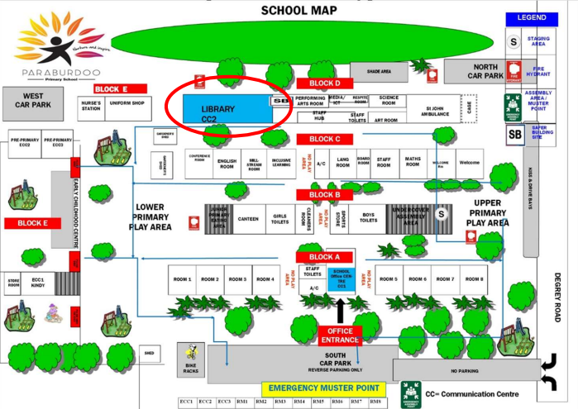 | Emergency, dial 000  Primary action:  Determine if the bushfire is a threat to the school. Monitor official sources listed in section 2.  Secondary action:  Refer to Appendix B for the procedures to relocate to onsite ‘safer building location(s).
 | Library
  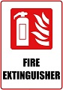      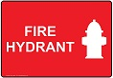 | Feb 2024

7.2 Offsite evacuation locations

Insert the school site map and make sure it is marked with:
- an assembly area
- 2 offsite evacuation locations. These locations cannot be a park, reserve, oval or other open space that may expose people to heat or other conditions.
- suitable routes to access the 2 locations.

Information to help select your offsite evacuation location and a sample map is available on Ikon in Prepare for bushfire season at your school.

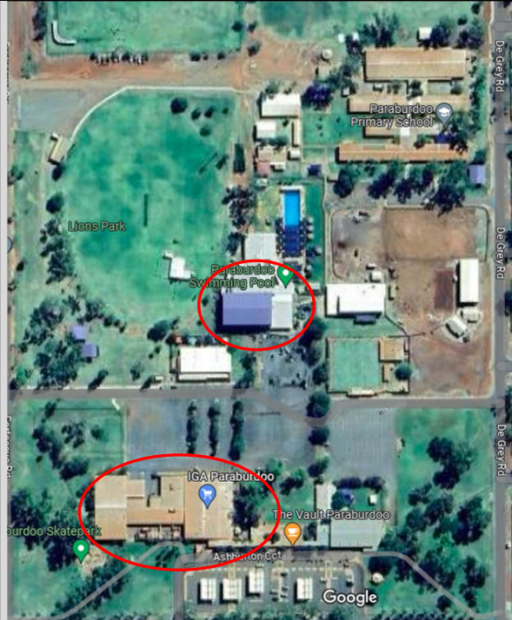[insert school map] | Emergency, dial 000  Primary action:  Determine if the bushfire is a threat to the school. Monitor official sources listed in section 2.  Secondary action:  Refer to Appendix B for the procedures to Relocate to an offsite evacuation location
Paraburdoo shopping centre, Ashburton Ave, Paraburdoo

Paraburdoo Community Hub (on accessible days), Anzac Rd Paraburdoo

Map last updated:
August 2023

Appendix A - Bushfire warning stages

Emergency services communicate information in a number of ways during a bushfire event. Use these warnings to understand when your need to activate your bushfire procedures (refer to Appendix B).

Bushfire warning stages
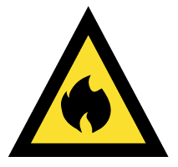  ADVICE | A fire has started, be aware and keep up to date.  This is general information to keep principals informed and up to date with developments.  Principals must:  - turn off evaporative air conditioners and ensure roof vents are closed.  - check and patrol the school regularly for bushfire activity, paying particular attention to the evaporative air conditioners.
WATCH AND ACT  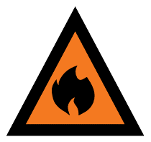 | There is a possible threat to lives and property. Conditions are changing.  Principals must prepare to:  - evacuate; or  - move students, staff and visitors to their pre-determined onsite ‘safer building location’. They must not be moved to an open area.  Evacuation orders are:  - issued by the Incident Controller or Emergency Services if required.  - relayed via official sources such as Emergency WA.  It is vital that the principal:  - accesses bushfire information from official sources  - makes an informed decision to stay onsite or evacuate offsite based on advice from the Incident Controller or Emergency Services.
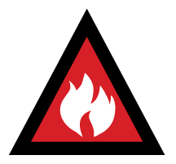  EMERGENCY | A school is in danger as its area will be impacted by fire. Take immediate action to survive.  The principal will be advised whether staff, students and visitors can leave the area or if they must shelter where they are as the fire burns through the area.  A siren, called the State Emergency Warning Signal (SEWS), may accompany an emergency warning.  Evacuation orders are:  - directed by the Incident Controller or Emergency Services.  - relayed via official sources, such as Emergency WA.  It is vital that the principal:  - accesses bushfire information from official sources  - makes an informed decision to stay onsite or evacuate offsite based on the advice.

Appendix B - Procedures in the event of a sudden bushfire

Relocate to onsite ‘safer building location’

You may be instructed to relocate to your onsite ‘safer building location(s)’. Do not use an open area such as a school oval or non-enclosed building.

Initiate this procedure if either of the following occurs:

- a ‘Watch and Act’ or ‘Emergency Warning’ alert is issued on the Emergency WA website (refer to Appendix A for details about the alerts)
- instruction from the Department of Fire and Emergency Services, Emergency Services or your Director of Education.

Follow these procedures to relocate to the onsite safer building location(s).

Action | Notes (if required)
Dial 000 for emergency services and request fire brigade.

When connected to Department of Fire and Emergency Services, advise:
- your school name and address
- the fire situation
- how many students and staff are being impacted
- if moving to a ‘safer building location’ and where it is located
- if anyone requires medical attention
- CB radio channel, if being used.
Remain in contact with the Department of Fire and Emergency Services.

Monitor official bushfire emergency information contact sources in section 2.1.

Activate your school response team to carry out their responsibilities (section 3).

Use your emergency response contact list to contact stakeholders (section 2).

Follow your bushfire response telephone call tree (section 4) to communicate with the school community.

Ensure parents receive emergency text message alerts to:
- inform them of relocation
- keep them updated (use the emergency text message alert templates, refer to Manage bushfire incident communications on Ikon).

Parents must not collect students until instructed.

Confirm:
- evaporative air conditioners are turned off
- all building roof vents, windows and doors are closed before anyone enters the onsite safer building location(s).
- where possible and safe to do so, relocate vehicles or other combustible items (school bags, rubbish bins etc) at least 20 metres from safer building locations.
- monitor embers for possible ignition.

Take emergency equipment (section 5):
- registers for students, staff and visitors
- evacuation kit
- water
- mobile phones (charged)
- student medication

Sound the school emergency warning or alert system.

Follow advice from the incident controller, emergency services, the Manager Security and Emergency Management or the director of education to move to the onsite safer building location(s) (section 7.1)

Students and staff must remain in classrooms unless they are directed to move to an onsite safer building location.

Check student, staff and visitor registers after moving to an onsite safer building location (roll call). Advise the police if anyone is missing.

You must give special consideration to students with known respiratory conditions.

Wait for emergency services to arrive or the incident controller to provide you with information.

Ongoing advice will also be provided by the Manager, Security and Emergency Management or the director of education.

Continue to monitor official bushfire information sources listed in section 2.1.

The Department will consult the incident controller or emergency services and notify you when it is safe to return to classrooms or for students to be collected by parents. You will receive advice from the director of education.

Offsite evacuation procedures

You may be instructed to relocate to your offsite evacuation location.

Initiate your offsite evacuation procedure if a ‘watch and act’ or ‘emergency warning’ bushfire warning alert on the Emergency WA website is invoked (refer to the bushfire warnings listed in Appendix A) and you receive direction from either:
- Department of Fire and Emergency Services, incident controller or emergency services

or
- the director of education.

Follow these procedures if you need to evacuate to an offsite evacuation location during a bushfire event.

Action | Notes (if required)
Dial 000 for emergency services and request fire brigade.

When connected to Department of Fire and Emergency Services, advise:
- your school name and address
- the fire situation
- how many students and staff are being impacted
- if moving to a ‘safer building location’ and where it is located
- if anyone requires medical attention
- CB radio channel, if being used.

Remain in contact with Department of Fire and Emergency Services and your director of education.

Monitor official bushfire emergency information contact sources listed in section 2.1.

Activate your School response team to carry out their responsibilities (section 3).

Refer to the Emergency response contact list to contact stakeholders (section 2).

Follow advice from the emergency services or the Manager, Security and Emergency Management or the director of education to decide which of the school’s offsite evacuation location(s) is the safest to use (section 7.2).

If safe to do so, muster at the identified assembly area where staff, students and visitors can gather to prepare for offsite evacuation.

Use an alternative assembly area if your first identified assembly area is unsafe.

Note: Students and staff must remain in classrooms unless they are directed to move to an onsite safer building location and/or onsite assembly area.
Follow the Bushfire response telephone call tree to communicate with the school community (section 4).

Ensure parents and carers receive emergency SMS alerts to:
- inform them of relocation
- keep them updated (use the emergency text message alert templates, refer to Manage bushfire incident communications on Ikon).

Note: Parents must not collect students until instructed.

Confirm:
- evaporative air conditioners are turned off
- building roof vents and doors are closed.

Take emergency equipment (section 5):
- registers for students, staff and visitors
- evacuation kit
- mobile phones (charged).
- student medication.

Sound the school emergency warning or alert system.

- Notify bus operators  - Notify other contractors scheduled to visit the site  - Move all students, staff and visitors from the assembly area to the offsite evacuation location. | No bus operators Contact St John Contact Shire or IGA, depending on evacuation point selected to advise of students arriving on site
Check registers after evacuating staff, students and visitors (roll call). Advise the police if anyone is missing.

The Manager, Security and Emergency Management or the director of education will provide ongoing advice.
Continue to monitor official bushfire information sources listed in section 2.1.

The Department will consult the incident controller or emergency services and notify you when it is safe to return to classrooms or for students to be collected by parents.
You will receive advice from the director of education.

Appendix C - Pre-emptive (planned) closure procedures

You may be instructed to pre-emptively close your school due to a fire behaviour index of 75 (extreme fire danger) or greater being forecast.

Initiate the closure procedure if you receive advice from the director of education or the Security and Emergency Management unit.

Follow these procedures for a planned school closure.

Action | Notes (if required)
Monitor official bushfire emergency information contact sources listed in section 2.1.

Activate your School response team to carry out their responsibilities (section 3).

Communicate the pre-emptive closure, continued closure or school reopening:
- use your Emergency response contact list to contact stakeholders (section 2)
- use your Bushfire response telephone tree (section 4)
- use communication templates in Manage bushfire incident communications for SMS, social media posts and Connect notices to keep the school community informed
- place the notice of temporary closure on external school access points and on the school website.

Note: Contact lists for staff, parents and carers must be current.

Confirm:  - windows and doors are closed  - evaporative air conditioners are turned off  - roof vents closed  - money is removed from the school premises  - expensive items of equipment secured. | There are no evaporative air conditioners on site
Secure school premises and activate security system.
Before departing, email AssetPlanningServices.SecurityEM@education.wa.edu.au or call 9264 4632 to confirm:
- all security systems armed
- site is secure.

When the pre-emptive closure is cancelled, remove the notice of temporary closure from external school access points.

Refer to the following Flow chart – Principal’s response to fire behaviour index of 75 (extreme fire danger) or greater forecast.

Flow chart – Principal’s response to Fire Behaviour Index of 75 (Extreme Fire Danger Rating) or greater
Principal notifies school community closure will not go ahead – school will open as normal.
Deputy Director General Schools and Manager, Security and Emergency Management decide if a school is to reopen.
The Director of Education will instruct the Principal.
Principal notifies the school community whether school remains closed or reopens.
Delegated officer invokes pre-closure prior to 4.30
Principal follows the pre-emptive closure procedure
(refer to Standalone bushfire plan).
Fire Behaviour Index of 75 (Extreme Fire Danger) or greater forecast has been declared.

NO
YES
Director of Education notifies the principal to prepare for pre-emptive closure.

Appendix D – After-hours or school holiday procedures

You may be instructed to keep your school closed during the school holidays or after hours during a bushfire event.

Initiate the below procedure if both of the following occur:

- A ‘Watch and act’ or ‘Emergency warning’ bushfire warning alert on the Emergency WA website is invoked (refer to the bushfire warnings listed in Appendix A)

AND
- Direction received from the Deputy Director General, Schools or the Manager, Security and Emergency Management. The director of education will relay the decision to you.

Follow these procedures if a bushfire starts during the school holidays or after hours.

Action | Notes (if required)
Remain in contact with your director of education and monitor official bushfire emergency information contact sources listed in section 2.1. | During school holidays, nominate a staff member who will remain in town to act as contact person and inform principal if principal is not in the area.
Use your emergency response contact list to contact stakeholders (refer to section 2).

Follow the bushfire response telephone call tree to communicate with the school community.

Send parents and carers and staff emergency text message alerts to inform them of the school closure. To access sample SMS text, refer to Manage bushfire incident communications.

Work with the director of education to seek alternative school and transport arrangements (if required).

The Department’s Media Unit and Incident Support Unit uses media outlets and Emergency WA to make public announcements of:
- the school closure
- temporary alternative accommodation.

The Department will consult the incident controller or emergency services and notify you when it is safe for the school to reopen.
You will receive advice from the director of education or the Manager, Security and Emergency Management.

Send parents, carers and staff emergency text message alerts to inform them when school can reopen.

